**Peer review sheet**

MAFS6010Z, 2021 fall

Your name and sid: Xinyu Tian, 20750015

Group that you review: 13

|  |  |  |  |  |
| --- | --- | --- | --- | --- |
|  | Confidence on your assessment (1-3) | Clarity and quality of writing (1-5) | Technical quality  (1-5) | Overall rating  (1-5) |
| Score | 3 | 3 | 3 | 3 |

Summary:

Based on the paper, they use different machine learning methods to work out the problem and focus on the analysis of the variable importance. Besides, they make some simplifications and adjustments for the preliminary study based on their understanding and the limitation of the machine environment capability.

Strengths:

1. Do basic analysis and preprocessing of variables.
2. Use various models to fit the dataset and analyze the feature importance.

Weaknesses:

1. The initial Sample Splitting is wrong.
2. Some models that adopt a recursive performance evaluation scheme do not run successfully.文本

   描述已自动生成
3. The out of sample R square obtained by recursive calculation is not shown. 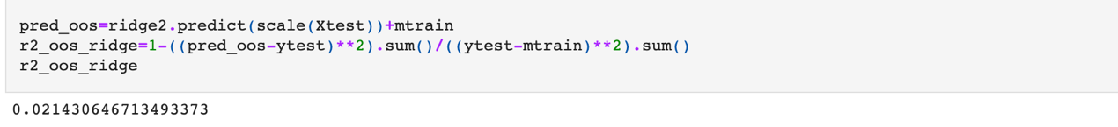
4. The models do not tune the parameters recursively.

1. The method of calculating feature importance is different from the paper.图形用户界面, 文本, 应用程序, 电子邮件

   描述已自动生成

Clarity and writing:

1. Pay attention to the grammar. For example,

1. No Figure 6-5.

Technical quality:

The report does not adopt a recursive performance evaluation scheme. The detailed problems are explained in the ‘Weaknesses’ part.